EMPAST National Report
Table of Contents
1. EMPAST National Report 1
1.1. National Report Summary 2
1.2. Data completeness 3
1.3. Unit-level setup summary 3
1.3.1. One stop clinic 3
1.3.2. Triage arrangements 3
1.3.3. Initial consultation arrangements 3
1.3.4. Testicular sparing surgery access 3
1.4. National diagnostic cohort measures 4
1.4.1. National diagnostic pathway timeline and proposed targets 4
1.4.2. GP pre-referral ultrasound 4
1.4.3. Diagnostic pathway KPIs 4
1.4.4. Sperm banking and prosthesis documentation 5
1.4.5. Delivery of results consultation 5
1.4.6. Benign pathway outcomes 5
1.4.7. Tumor markers taken when US shows benign pathology 5
1.5. National confirmed cancer cohort measures 6
1.5.1. Summary measures 6
1.5.2. Timing 6
1.5.3. Histology 6
1.5.4. Contralateral biopsy if risk factors present 7
1.5.5. Readmissions 7
1.5.6. Supra-regional MDT outcome by histology and stage 7
1.6. Models 9
1.6.1. Seen within 14 days 9
1.6.2. FDS proxy within 28 days 9
1.6.3. Benign pathway: Odds of not being discharged by grade 10
1.6.4. Complications 10
1.7. National KPI Figures 11
1.7.1. Seen within 14 days 11
1.7.2. FDS proxy within 28 days 12
1.7.1. Median days from referral to orchidectomy 13
1.7.2. 30-day readmissions 14
1.8. Survival 15
1.8.1. Event Free Survival by tumor histology 15
1.8.2. Event Free Survival by time from referral to orchidectomy 15
1.9. Appendix 16

National Report Summary

Generated: 2026-01-18
Total records: 1818 | Diagnostic cohort: 773 | Confirmed cancer cohort: 947

Thank you to all participating units and clinicians for submitting data to EMPAST. Your contributions enable a national view of testicular cancer pathway performance and variation, supporting quality improvement and benchmarking across services.

Across 1,818 EMPAST submissions (773 diagnostic and 947 confirmed cancer), national diagnostic pathway performance was generally strong for timeliness, with a median of 7.5 days from referral to first consultation and 79% seen within 14 days, alongside a median of 14 days from referral to outcome communication and 81% meeting the FDS proxy within 28 days. However, only 18.6% of diagnostic cases had GP pre referral ultrasound recorded, and this subgroup had a markedly higher cancer detection rate (60% versus 9.7% without pre referral ultrasound), suggesting important differences in case mix and a potential opportunity to streamline pathways through earlier imaging. Documentation of fertility and prosthesis counselling in the diagnostic setting remained inconsistent, with sperm banking documentation or offer recorded in 48.6% and prosthesis documentation or offer recorded in 54.2% of cases with adequate data.

In the confirmed cancer cohort, median pathway intervals were 23 days from referral to orchidectomy, 10 days from orchidectomy to cross sectional imaging, and 13 days from imaging to supra regional MDT, while 11.2% had imaging dated after MDT, indicating potentially avoidable sequencing delays. Post orchidectomy tumour marker practice and prosthesis use were additional improvement areas, with tumour markers not repeated within 2 weeks in 52.4% and prosthesis insertion recorded in 19.6% of confirmed cases. Furthermore, only 8% of patients with indications for a contralateral testicular biopsy actually underwent the procedure. Readmission remained relatively low at below 7%.

Practical levers to improve speed and reliability include direct triage models that bypass an initial clinic appointment for clearly suspicious referrals, one stop pathways with same day ultrasound and tumour markers, expanded CNS led coordination for booking and follow up, and ensuring cross sectional imaging is completed before MDT wherever possible.

Omar El-Taji & Vish Hanchanale
BAUS Section of Oncology

Data completeness
Dataset | n | Unit present | Referral date | First Consult Date | Orchidectomy Date | Latest follow up
All submissions | 1,818 | 100% | N/A | N/A | N/A | N/A
Diagnostic cohort | 773 | 100% | 100% | 88.7% | N/A | N/A
Confirmed cohort | 947 | 100% | 99.9% | 88.7% | 99.9% | 72.8%

Unit-level setup summary

One stop clinic
One stop clinic | Units (n)
No | 61 | 57%
Yes | 33 | 30.8%
Missing | 13 | 12.1%

Triage arrangements
Majority triage performed by | Units (n)
Administrative staff | 17 | 15.9%
Clinical Nurse Specialist | 30 | 28%
Consultant | 42 | 39.3%
Urology Trainee or Trust grade Doctor | 4 | 3.7%
Missing | 14 | 13.1%

Initial consultation arrangements
Initial consultation performed as | Units (n)
Face to Face | 86 | 80.4%
Telephone | 7 | 6.5%
Other (triage) | 14 | 13.1%

Testicular sparing surgery access
Offers partial orchidectomy | Can refer locally for testicular sparing surgery | No access to testicular sparing surgery
21.5% | 44.9% | 33.6%

National diagnostic cohort measures

National diagnostic pathway timeline and proposed targets

GP pre-referral ultrasound
Diagnostic cases adequate data | Pre-Referral US | % of pre-referral US from total cohort | Number of cancers in those with pre-referral US
733 | 136 | 18.6 | 81/136 (60%)

Diagnostic cases adequate data | No pre-referral US | % of non pre-referral US from total cohort | Number of cancers in those with No pre-referral US
733 | 597 | 81% | 58/597 (9.7%)
ARR 50% OR 13.6 (95% CI 8.6-21.7, p <0.001)

Diagnostic pathway KPIs
Metric | Overall  (n=733) | Pre-Referral US (n=136) | No Pre-Referral US (n= 597)
Referral to first consultation median days (IQR) | 7.5 (5-14) | 7 (2.5-11) | 8 (5-14)
Seen within 14 days | 79% | 89% | 77%
Referral to outcome communicated median days (IQR) | 14 (8-25) | 11 (6-22) | 15 (9-25)
FDS within 28 days | 81% | 81% | 81%
Cancer detection | 18% | 60% | 9.7%

Sperm banking and prosthesis documentation
Metric | Adequate Data | n | Percent
Sperm banking documentation or offer recorded | 107 | 52 | 48.6%
Prosthesis documentation or offer recorded | 107 | 58 | 54.2%

Delivery of results consultation
Clinician | n
Consultant | 399 | 51.6%
Trainee | 279 | 36.1%
Clinical Nurse Specialist | 61 | 7.9%
Other | 34 | 4.4%

Benign pathway outcomes
Benign Outcome | n
Reassured then discharged | 396 | 76.6%
Listed for benign procedure | 41 | 7.9%
Further clinic follow up | 80 | 15.5%

Tumor markers taken when US shows benign pathology

US Results | n | TM taken (n)
US not benign | 215 | 145 | 67.4%
US shows benign pathology | 518 | 83 | 16%

National confirmed cancer cohort measures

Summary measures

Metric | n
30-day readmission | 62 | 6.5%
First follow up post orchidectomy by urology | 576 | 60.8%
First follow up post orchidectomy by oncology | 371 | 39.2%
Tumor marker NOT repeated within 2 weeks post orchidectomy | 497 | 52.4%
Charleston Co-morbidity index of ≤ 3 | 932 | 98.5%
Prosthesis insertion | 186 | 19.6%

Timing

Metric
Referral to orchidectomy median days (IQR) | 23 (15-35)
Orchidectomy to imaging median days (IQR) | 10 (5-21)
Imaging to supra-regional MDT median days (IQR) | 13 (6-26)
Orchidectomy to supra-regional MDT median days | 27 (20-42)
84/750 (11.2%) have imaging dated after MDT

Histology

Histology | n
Seminoma | 568 | 60%
NSGCT (incl mixed) | 316 | 33.4%
Other | 59 | 6.2%
Sex cord tumour | 4 | 0.4%

Contralateral biopsy if risk factors present

With risk factors in contralateral testicle | Offered and Performed | %
112 | 9 | 8

Readmissions
Readmission | n | %
superficial wound infection | 30 | 48.4
deep collection | 9 | 14.5
haematoma | 20 | 32.3
seroma | 1 | 1.6
sepsis | 1 | 1.6
cardiac event | 1 | 1.6
Total | 62

Supra-regional MDT outcome by histology and stage

Histology subtype | Staging | Supra-regional MDT outcome | n
NSGCT (incl mixed) | N+ / M+ | Chemotherapy | 38 | 66.7%
NSGCT (incl mixed) | N+ / M+ | Oncology Surveillance | 14 | 24.6%
NSGCT (incl mixed) | N+ / M+ | Primary RPLND | 5 | 8.8%
NSGCT (incl mixed) | N+ / M0 | Chemotherapy | 43 | 76.8%
NSGCT (incl mixed) | N+ / M0 | Oncology Surveillance | 11 | 19.6%
NSGCT (incl mixed) | N+ / M0 | Primary RPLND | 2 | 3.6%
NSGCT (incl mixed) | N0 / M+ | Chemotherapy | 6 | 60%
NSGCT (incl mixed) | N0 / M+ | Oncology Surveillance | 4 | 40%
NSGCT (incl mixed) | N0 / M0 | Chemotherapy | 81 | 42%
NSGCT (incl mixed) | N0 / M0 | Oncology Surveillance | 110 | 57%
NSGCT (incl mixed) | N0 / M0 | Primary RPLND | 2 | 1%
Other | N+ / M+ | Chemotherapy | 10 | 58.8%
Other | N+ / M+ | Oncology Surveillance | 7 | 41.2%
Other | N+ / M0 | Chemotherapy | 3 | 50%
Other | N+ / M0 | Oncology Surveillance | 2 | 33.3%
Other | N+ / M0 | Primary RPLND | 1 | 16.7%
Other | N0 / M+ | Chemotherapy | 1 | 100%
Other | N0 / M0 | Chemotherapy | 5 | 14.7%
Other | N0 / M0 | Oncology Surveillance | 26 | 76.5%
Other | N0 / M0 | Radiotherapy | 3 | 8.8%
Seminoma | N+ / M+ | Chemotherapy | 46 | 63%
Seminoma | N+ / M+ | Oncology Surveillance | 24 | 32.9%
Seminoma | N+ / M+ | Primary RPLND | 1 | 1.4%
Seminoma | N+ / M+ | Radiotherapy | 2 | 2.7%
Seminoma | N+ / M0 | Chemotherapy | 46 | 64.8%
Seminoma | N+ / M0 | Oncology Surveillance | 21 | 29.6%
Seminoma | N+ / M0 | Primary RPLND | 2 | 2.8%
Seminoma | N+ / M0 | Radiotherapy | 2 | 2.8%
Seminoma | N0 / M+ | Chemotherapy | 3 | 42.9%
Seminoma | N0 / M+ | Oncology Surveillance | 4 | 57.1%
Seminoma | N0 / M0 | Chemotherapy | 167 | 40%
Seminoma | N0 / M0 | Oncology Surveillance | 246 | 59%
Seminoma | N0 / M0 | Primary RPLND | 1 | 0.2%
Seminoma | N0 / M0 | Radiotherapy | 3 | 0.7%
Sex cord tumor | N0 / M0 | Chemotherapy | 2 | 50%
Sex cord tumor | N0 / M0 | Oncology Surveillance | 2 | 50%

Models

Seen within 14 days

FDS proxy |  | OR | 95% CI | p value
Face to Face |  | Reference
Telephone |  | 1.68 | 0.68 to 4.16 | 0.264
No Pre-referral US | Reference
Pre-referral US |  | 2.49 | 1.34 to 4.62 | 0.003
Consultant |  | Reference
Clinical Nurse Specialist |  | 6.08 | 1.67 to 22.11 | 0.006
Trainee |  | 2.02 | 1.34 to 3.04 | <0.001

FDS proxy within 28 days

FDS Proxy | OR | 95% CI | p value
Face to Face | Reference
Telephone | 0.56 | 0.25 to 1.24 | 0.151
Triage only | 4.76 | 1.97 to 23.35 | 0.046
No Pre-referral US | Reference
Pre-Referral US | 1.10 | 1.16 to 1.84 | 0.001
Consultant | Reference
Clinical Nurse Specialist | 6.15 | 1.86 to 20.3 | 0.002
Other | 0.54 | 0.12 to 2.4 | 0.420
Trainee | 0.97 | 0.65 to 1.44 | 0.872

Benign pathway: Odds of not being discharged by grade

Clinician | OR | 95% CI | p value
Consultant | Reference
Clinical Nurse Specialist | 0.76 | 0.36 to 1.62 | 0.481
Trainee | 0.86 | 0.55 to 1.33 | 0.485

Complications

Predictor of complications | OR | 95% CI | p value
Charleston Co-morbidity index of <3 | Reference
Charleston Co-morbidity index of ≥ 3 | 2.42 | 0.53 to 11.08 | 0.253
No Prosthesis insertion | Reference
Prosthesis insertion | 1.02 | 0.23 to 1.15 | 0.945

National KPI Figures

Seen within 14 days

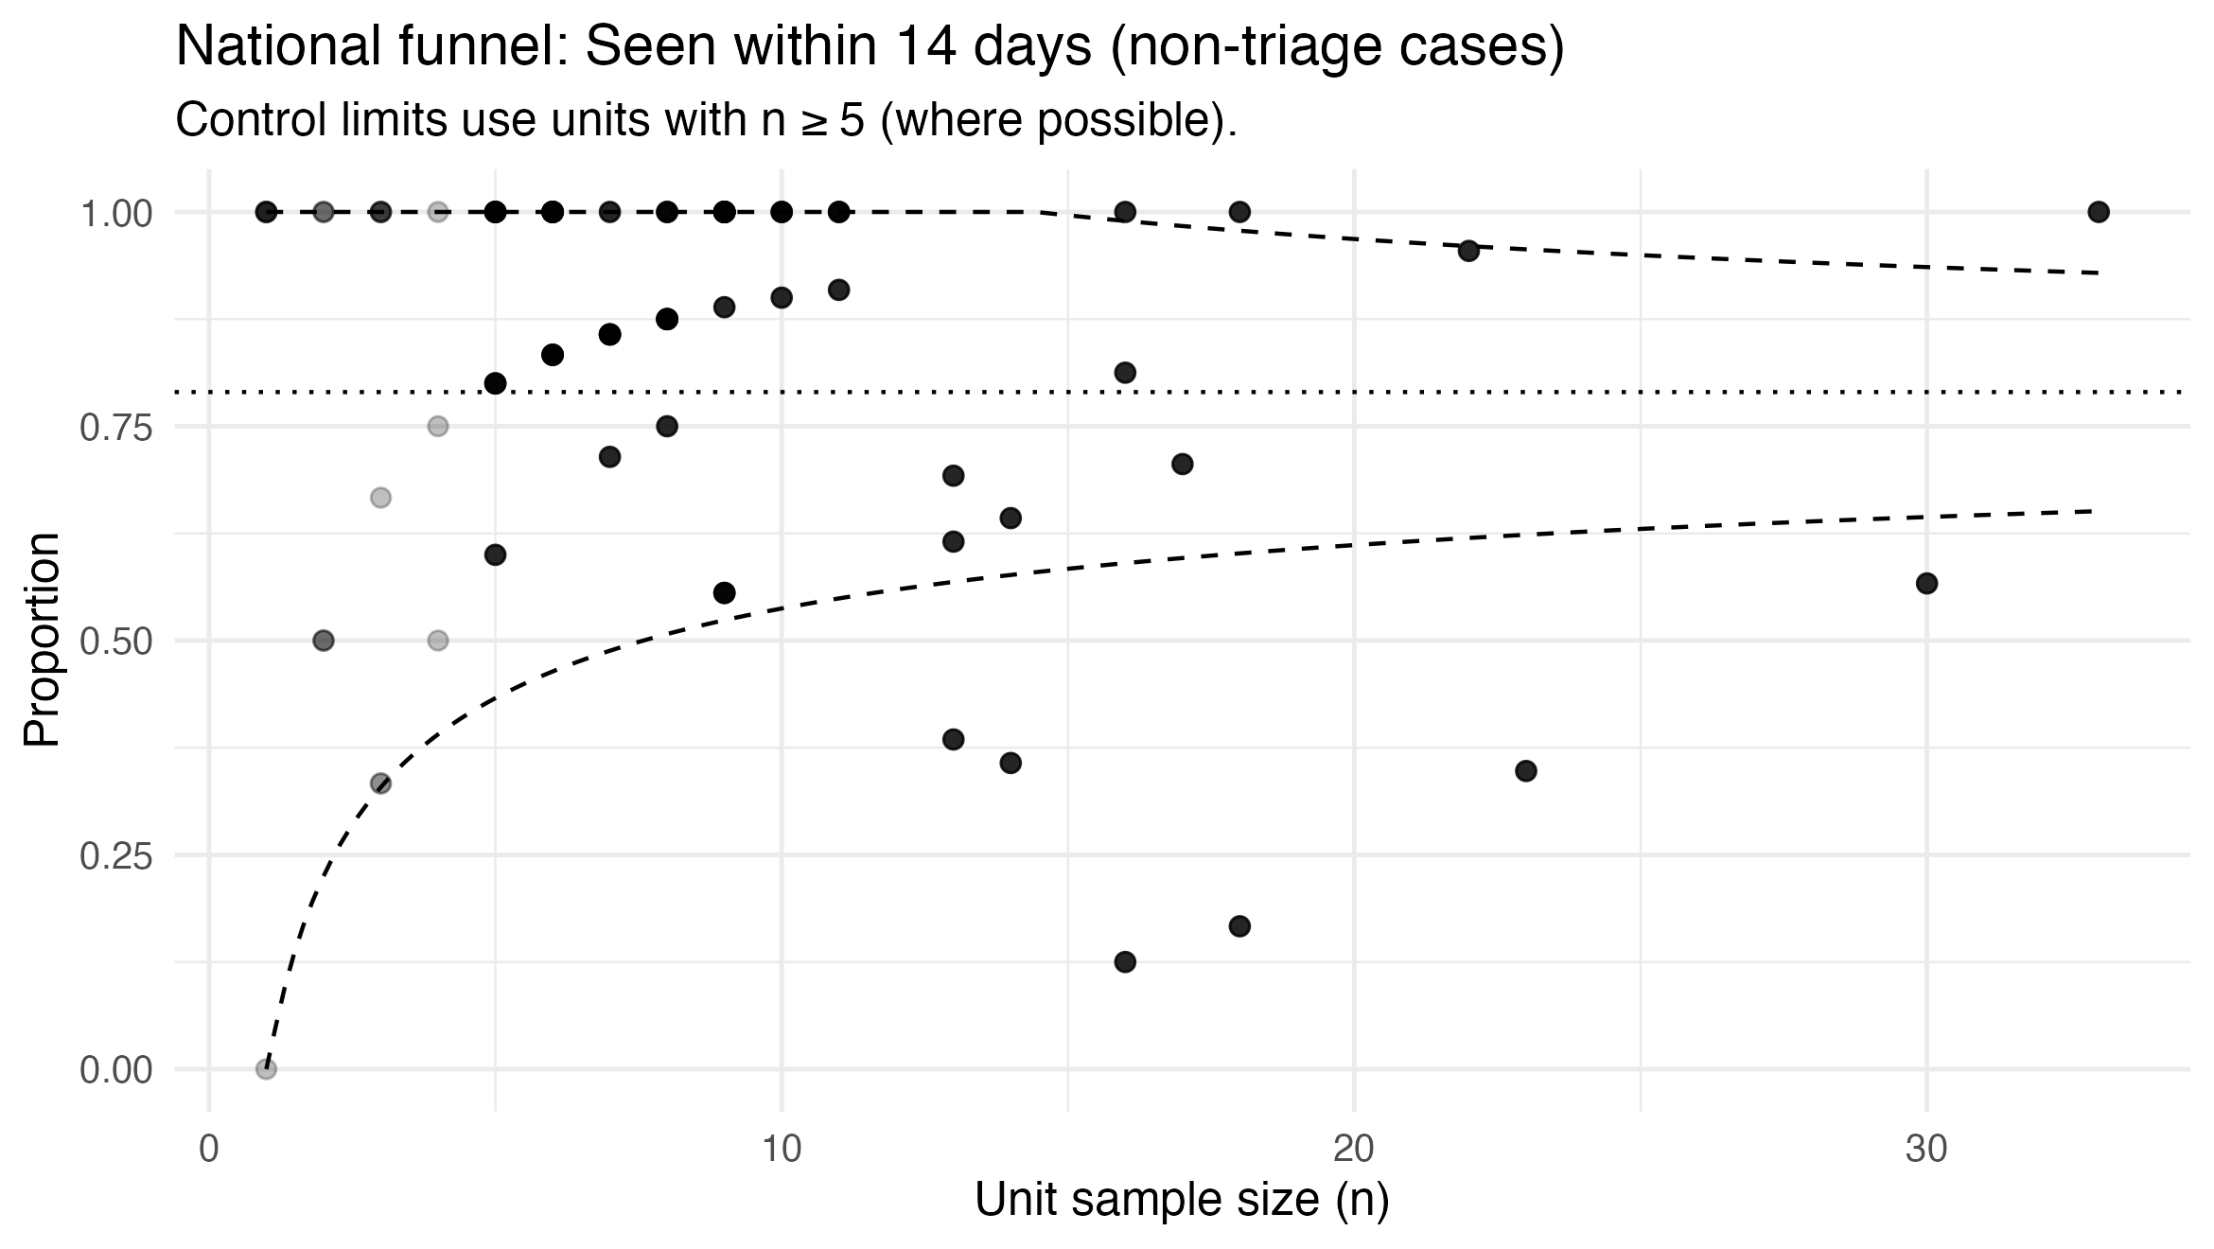
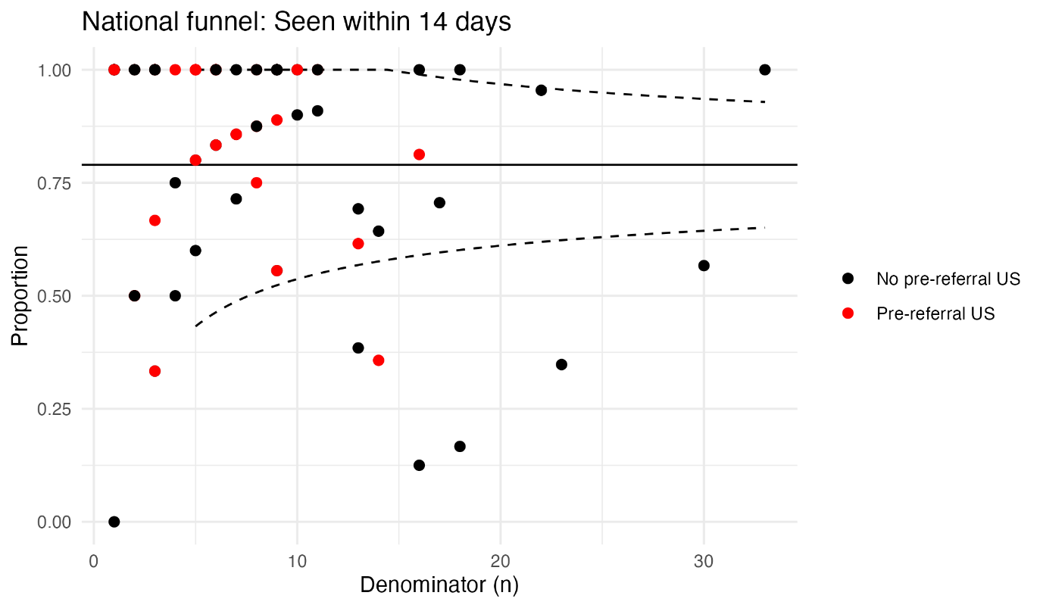

FDS proxy within 28 days

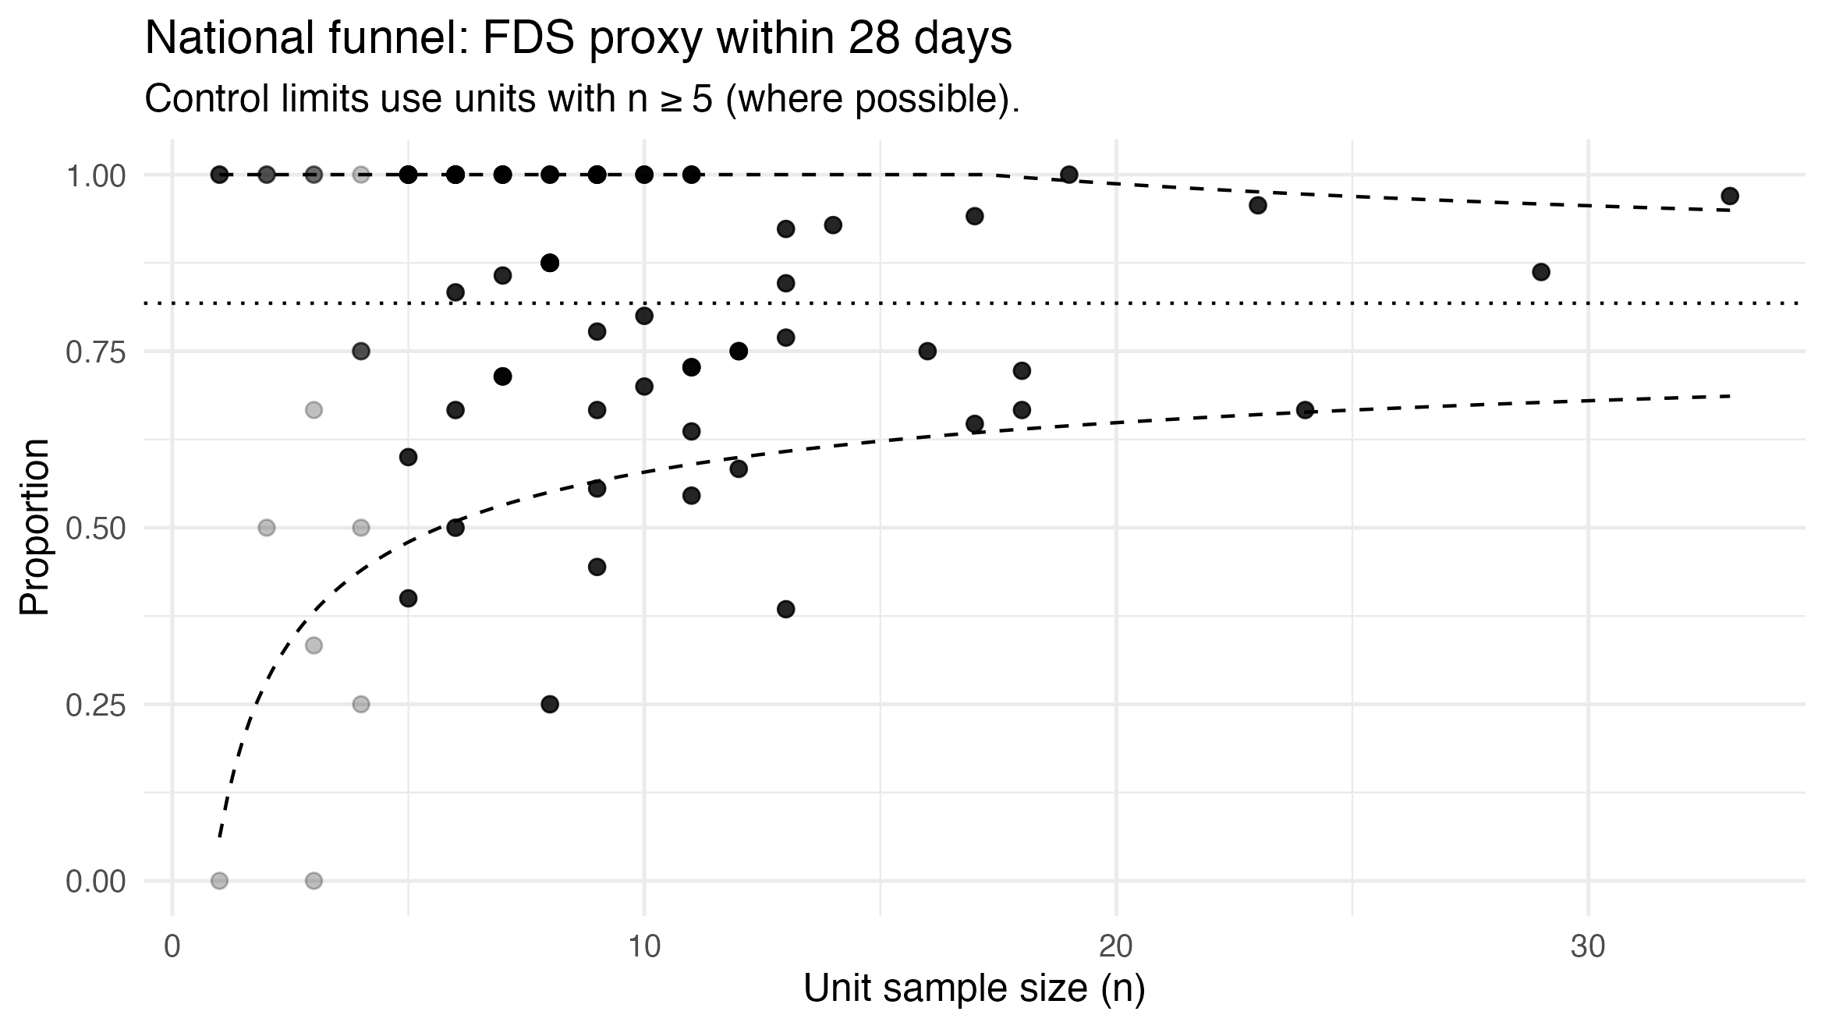

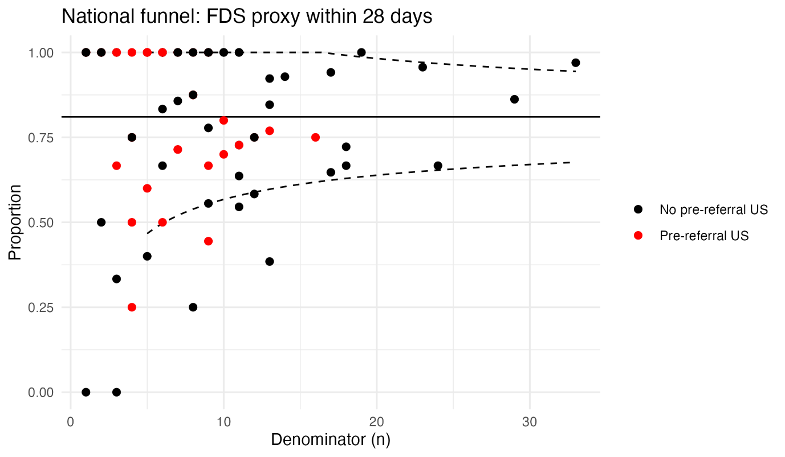

#

Median days from referral to orchidectomy

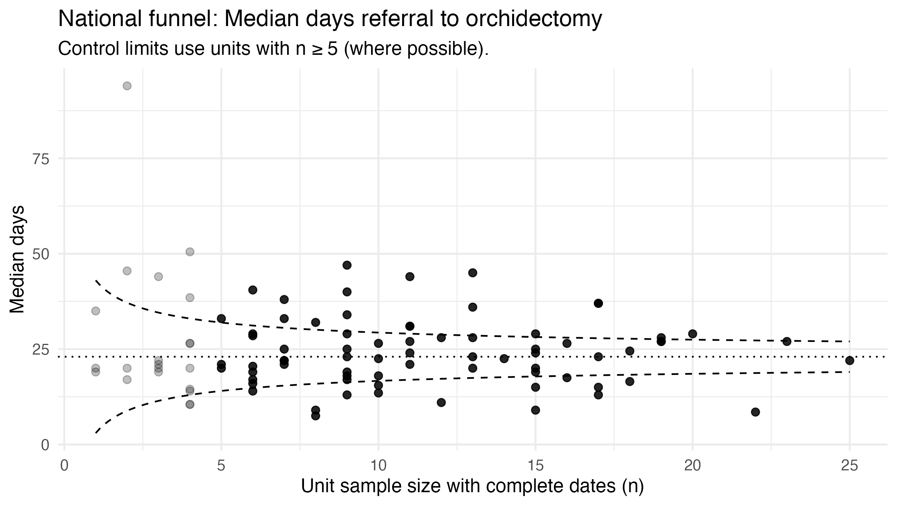

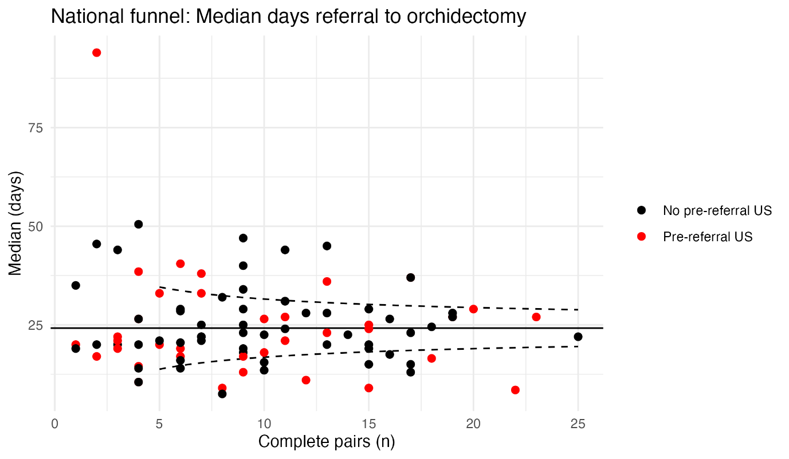

30-day readmissions

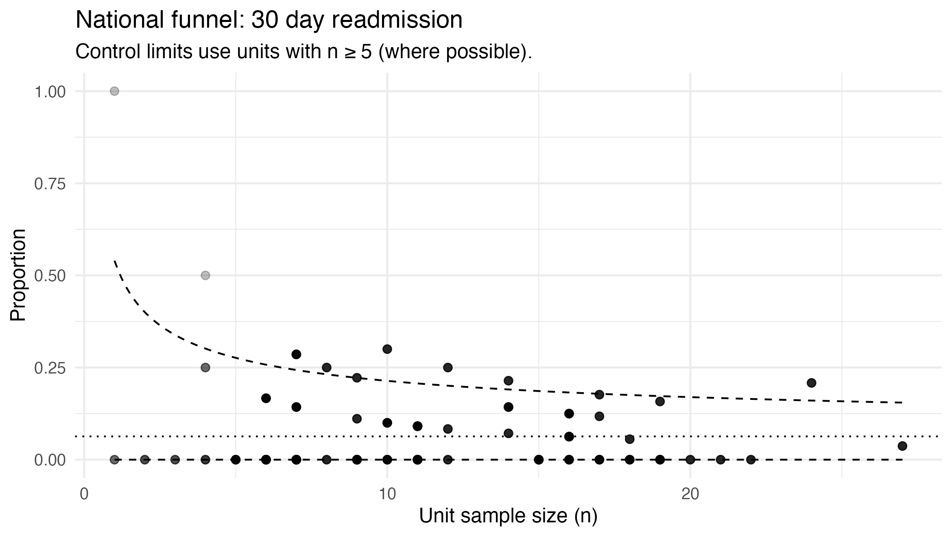

Survival

Event Free Survival by tumor histology

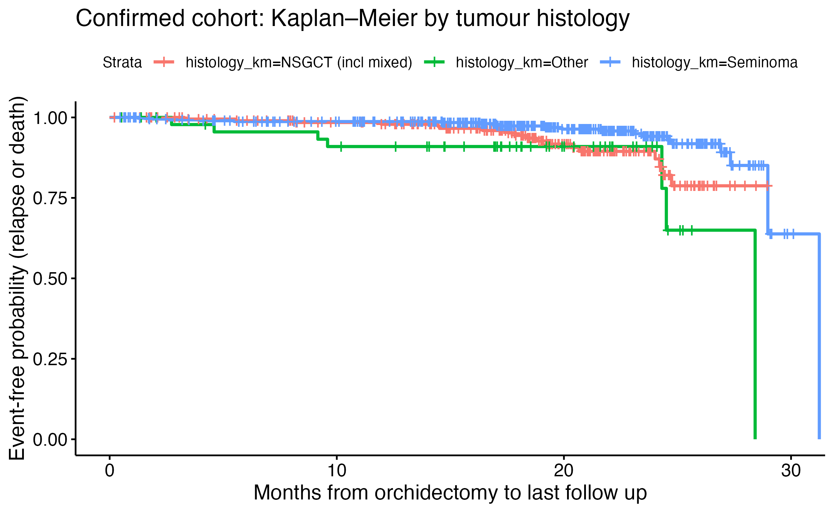

Event Free Survival by time from referral to orchidectomy

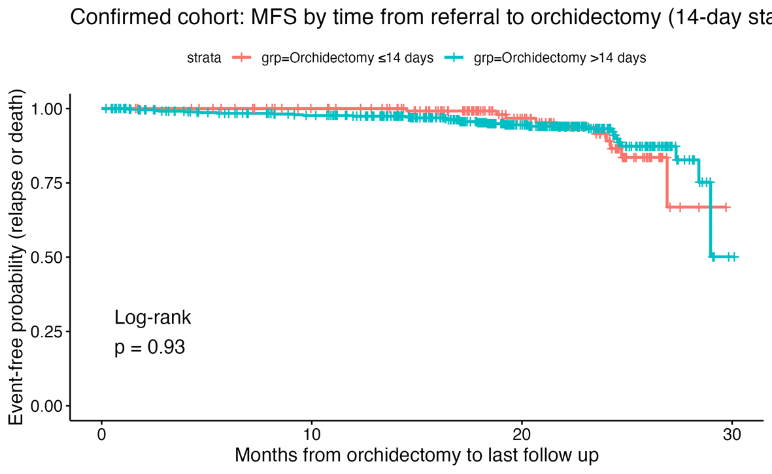

Appendix

Appendix: Diagnostic Cohort Submissions
Region | Unit | n
South Central | Royal Berkshire Hospital, Reading | 35
West Midlands | Royal Stoke University Hospital | 30
London North | Northwick Park Hospital | 25
East of England | Norfolk And Norwich University Hospital | 23
London South | St George's Hospital, London | 19
South West | Derriford Hospital, Plymouth | 19
Kent, Surrey, Sussex | Eastbourne District General Hospital | 18
Yorkshire & Humber | Doncaster Royal Infirmary | 18
East of England | Addenbrooke's Hospital, Cambridge | 17
East of England | Peterborough City Hospital | 17
West Midlands | New Cross Hospital, Wolverhampton | 16
North West | Royal Lancaster Infirmary | 15
North West | Wythenshawe Hospital, Manchester | 15
London North | Barking, Havering & Redbridge University Hospital | 14
London North | Royal Free Hospital, London | 14
South Central | Royal Bournemouth Hospital | 14
North East | Freeman Hospital, Newcastle | 13
South Central | Queen Alexandra Hospital, Portsmouth | 13
Kent, Surrey, Sussex | Medway Maritime Hospital, Gillingham | 12
Yorkshire & Humber | Rotherham Hospital | 12
East Midlands | Chesterfield Royal Hospital | 11
Kent, Surrey, Sussex | Princess Royal Hospital, Haywards Heath | 11
North West | Royal Liverpool University Hospital | 11
North West | Royal Oldham Hospital | 11
South Central | Basingstoke and North Hampshire Hospital | 11
East of England | James Paget University Hospital, Great Yarmouth | 10
East of England | Luton & Dunstable University Hospital | 10
Kent, Surrey, Sussex | East Surrey Hospital, Redhill | 10
London South | Croydon University Hospital, Surrey | 10
North West | Arrowe Park Hospital, Wirral | 10
Kent, Surrey, Sussex | St Peter's Hospital, Chertsey | 9
London South | Queen Elizabeth Hospital, Woolwich | 9
North West | Royal Preston Hospital | 9
South West | Royal Cornwall Hospital, Truro | 9
South West | Royal United Hospital, Bath | 9
West Midlands | University Hospital, Coventry | 9
Yorkshire & Humber | Harrogate District Hospital | 9
Yorkshire & Humber | Huddersfield Royal Infirmary | 9
East Midlands | Lincoln County Hospital | 8
Kent, Surrey, Sussex | Darent Valley Hospital, Kent | 8
London North | Chelsea & Westminster Hospital, London | 8
North West | Manchester Royal Infirmary | 8
South Central | Wexham Park Hospital, Slough | 8
South West | The Great Western Hospital, Swindon | 8
West Midlands | Warwick Hospital | 8
Yorkshire & Humber | Barnsley Hospital | 8
East Midlands | Northampton General Hospital | 7
East of England | The Queen Elizabeth Hospital, King's Lynn | 7
Kent, Surrey, Sussex | Ashford Hospital, Middlesex | 7
North West | Leighton Hospital, Cheshire | 7
North West | North Manchester General Hospital | 7
North West | Stepping Hill Hospital, Stockport | 7
South West | Royal Devon and Exeter Hospital | 7
East of England | Ipswich Hospital, Suffolk | 6
East of England | West Suffolk Hospital | 6
Kent, Surrey, Sussex | Frimley Park Hospital | 6
London North | Hillingdon Hospital, Uxbridge | 6
London South | Kingston Hospital, London | 6
North West | Salford Royal Hospital | 6
North West | Whiston Hospital, Prescot | 6
Kent, Surrey, Sussex | Royal Surrey Hospital, Guildford | 5
North West | Blackpool Victoria Hospital | 5
South West | Cheltenham General Hospital | 5
Yorkshire & Humber | Airedale Hospital | 5
Yorkshire & Humber | Scunthorpe General Hospital | 5
Kent, Surrey, Sussex | Kent and Canterbury Hospital | 4
North East | The James Cook University Hospital, | 4
Northern Ireland | Craigavon Area Hospital, Portadown | 4
South West | Musgrove Park Hospital, Taunton | 4
South West | North Devon District Hospital | 4
Yorkshire & Humber | Royal Hallamshire Hospital, Sheffield | 4
North East | University Hospital of North Tees, Stockton-on-Tees | 3
North West | Aintree University Hospital, Liverpool | 3
North West | Southport And Ormskirk Hospitals | 3
South Central | Salisbury District Hospital | 3
West Midlands | Russells Hall Hospital, Dudley | 3
Kent, Surrey, Sussex | Worthing Hospital | 2
London North | Charing Cross Hospital, London | 2
North West | Royal Bolton Hospital | 2
Scotland East | Raigmore Hospital, Inverness | 2
Yorkshire & Humber | Castle Hill Hospital, Hull | 2
East of England | Bedford Hospital | 1
North West | Countess of Chester Hospital | 1
North West | Trafford General Hospital | 1
South West | Bristol Royal Infirmary | 1
Wales | Bronglais General Hospital, Aberystwyth | 1
Wales | Morriston Hospital, Swansea | 1
Yorkshire & Humber | Pinderfields General Hospital, Wakefield | 1

Appendix: Confirmed Cancer Cohort Submissions
Region | Unit | n
London North | Whipps Cross University Hospital, London | 27
South West | Musgrove Park Hospital, Taunton | 24
Kent, Surrey, Sussex | Princess Royal Hospital, Haywards Heath | 22
North West | Royal Oldham Hospital | 21
Northern Ireland | Craigavon Area Hospital, Portadown | 20
West Midlands | Royal Stoke University Hospital | 19
West Midlands | University Hospital, Coventry | 19
Yorkshire & Humber | Pinderfields General Hospital, Wakefield | 19
Kent, Surrey, Sussex | Frimley Park Hospital | 18
London South | St George's Hospital, London | 18
South West | Royal United Hospital, Bath | 18
East of England | Peterborough City Hospital | 17
Kent, Surrey, Sussex | East Surrey Hospital, Redhill | 17
West Midlands | New Cross Hospital, Wolverhampton | 17
Yorkshire & Humber | Royal Hallamshire Hospital, Sheffield | 17
London North | Northwick Park Hospital | 16
North West | Royal Liverpool University Hospital | 16
South Central | Queen Alexandra Hospital, Portsmouth | 16
South Central | Royal Berkshire Hospital, Reading | 16
South Central | Royal Bournemouth Hospital | 16
South West | Derriford Hospital, Plymouth | 16
South West | Royal Devon and Exeter Hospital | 16
Kent, Surrey, Sussex | Eastbourne District General Hospital | 15
London North | Hillingdon Hospital, Uxbridge | 15
Yorkshire & Humber | Castle Hill Hospital, Hull | 15
Kent, Surrey, Sussex | Kent and Canterbury Hospital | 14
North West | Manchester Royal Infirmary | 14
South West | Cheltenham General Hospital | 14
Yorkshire & Humber | Huddersfield Royal Infirmary | 14
London North | Barking, Havering & Redbridge University Hospital | 12
West Midlands | Alexandra Hospital, Redditch | 12
West Midlands | Russells Hall Hospital, Dudley | 12
East Midlands | Northampton General Hospital | 11
Kent, Surrey, Sussex | Royal Surrey Hospital, Guildford | 11
Kent, Surrey, Sussex | Worthing Hospital | 11
London North | Royal Free Hospital, London | 11
North East | Freeman Hospital, Newcastle | 11
North West | Blackpool Victoria Hospital | 11
North West | Whiston Hospital, Prescot | 11
North West | Wythenshawe Hospital, Manchester | 11
Wales | Morriston Hospital, Swansea | 11
Yorkshire & Humber | Scunthorpe General Hospital | 11
London North | Charing Cross Hospital, London | 10
London North | Whittington Hospital, London | 10
South Central | Basingstoke and North Hampshire Hospital | 10
West Midlands | George Eliot Hospital | 10
Yorkshire & Humber | Airedale Hospital | 10
East of England | Addenbrooke's Hospital, Cambridge | 9
East of England | Luton & Dunstable University Hospital | 9
East of England | Norfolk And Norwich University Hospital | 9
London South | Croydon University Hospital, Surrey | 9
North East | University Hospital of North Tees, Stockton-on-Tees | 9
Yorkshire & Humber | York Hospital | 9
Kent, Surrey, Sussex | Medway Maritime Hospital, Gillingham | 8
North East | The James Cook University Hospital, | 8
East Midlands | Chesterfield Royal Hospital | 7
East of England | Ipswich Hospital, Suffolk | 7
East of England | West Suffolk Hospital | 7
London North | Chelsea & Westminster Hospital, London | 7
North West | Royal Preston Hospital | 7
North West | Stepping Hill Hospital, Stockport | 7
South Central | Salisbury District Hospital | 7
South West | Royal Cornwall Hospital, Truro | 7
Wales | University Hospital of Wales, Cardiff | 7
East Midlands | Lincoln County Hospital | 6
Kent, Surrey, Sussex | Darent Valley Hospital, Kent | 6
London South | Kingston Hospital, London | 6
North West | Royal Bolton Hospital | 6
North West | Southport And Ormskirk Hospitals | 6
Yorkshire & Humber | Doncaster Royal Infirmary | 6
Yorkshire & Humber | Rotherham Hospital | 6
East of England | James Paget University Hospital, Great Yarmouth | 5
East of England | The Queen Elizabeth Hospital, King's Lynn | 5
Kent, Surrey, Sussex | St Peter's Hospital, Chertsey | 4
London South | Queen Elizabeth Hospital, Woolwich | 4
North West | Arrowe Park Hospital, Wirral | 4
North West | Royal Lancaster Infirmary | 4
North West | Salford Royal Hospital | 4
Scotland East | Raigmore Hospital, Inverness | 4
South Central | St Mary's Hospital, IOW | 4
West Midlands | Warwick Hospital | 4
Yorkshire & Humber | Harrogate District Hospital | 4
East of England | Bedford Hospital | 3
Kent, Surrey, Sussex | Ashford Hospital, Middlesex | 3
North West | Countess of Chester Hospital | 3
Yorkshire & Humber | Barnsley Hospital | 3
London North | Newham University Hospital, London | 2
North West | Aintree University Hospital, Liverpool | 2
North West | North Manchester General Hospital | 2
South West | North Devon District Hospital | 2
Kent, Surrey, Sussex | Maidstone Hospital | 1
South West | Bristol Royal Infirmary | 1
Wales | Bronglais General Hospital, Aberystwyth | 1
Yorkshire & Humber | Scarborough General Hospital | 1

